
St James Church of England Primary School
Wednesday News – 5th September 2018

WELCOME BACK
First day of school in September is one of my favourites, we look forward to seeing all the children arrive back with all their holiday news and excited to start the new school year and get on with some wonderful learning in their new year groups.
We ended last term with a wonderful send off for Mr Lanyon who is currently enjoying a very long holiday in France. We start this term with our leadership team in place with some very familiar faces. I began working here 12 years ago as a class teacher and have been heavily involved with the operational running of the school for the last 5 years. My more recent focus has been on improving and adapting the curriculum to ensure super learning opportunities and trips for the children as well as getting the inclusion team up and running to support the children. As a team of three, we have led the school on a number of occasions over the last 3 years and we constantly strive to achieve the best learning opportunities for the children and to ensure that they are all safe and happy here. If you want to share any concerns with us or simply say hello, you will generally find us out and about at the start or end of school days or speak with Mrs Sagoo in the office to arrange appointments.

Miss Cross Mrs Hanson Mrs Pritchard
Head Teacher Deputy Head Teacher Deputy Head Teacher
We look forward to meeting you throughout the school year - Miss Cross


KEY MESSAGE
This school year we are building on the fabulous Key Stage 2 results in July and we have a whole school focus on Growth Mindset. The message is clear – to be successful you must try and try again. We want children to embrace challenges and to be confident in their abilities. Determination and a can do approach will be encouraged in all children so that every child does their very best. Children will be exploring the skills they need to be successful over the next few weeks.
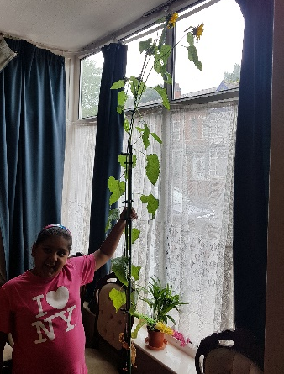
SUNFLOWER
Simran has been sending updates to school and the Sunflower has grown to the ceiling at home. Great to see lovely flowers – well done Simran! Anybody else with updates do please send them in and we will be giving out certificates in a few weeks.
Sadly, the organisers of the competition told me that their plants died. They have inspired some other gardens so well done Sana and Zahra.

BREAKFAST CLUB
The drop in breakfast club opens at 8.15am each morning with the gates opening just before this – it costs £1.00 which children should bring with them. All other children should be arriving at school at around 8.40am and be supervised while they wait for school doors to open at 8.45am.
SAFEGUARDING
October 2018
01.10.2018 | Individual and family photographs
10.10.2018 | 1C Lickey Hills trip
09.10.2018 | Black History Assembly led by Class 6M and Mr Mahmood
16.10.2018 | 2:30pm Harvest Assembly led by Class 1O
19.10.2018 | PGL Weekend for Y6 (3 nights returning on 22.10.2018)
23.10.2018 | 2:30pm Diwali Assembly led by Class 2M
26.10.2018 | School closes for Half Term @ 3.25pm
It is key that you contact school if your child isn’t attending school for illness or any other reason. We have a duty of care to know that everyone is safe and well. If we can’t make contact with you then we will try a home visit and then contact other services to support us in checking that everyone is safe and well. Please call 0121 523 5861.
September 2018
05.09.2018 | Start of the Autumn Term for Y1-Y6. School opens at 8.45
11.09.2018 | Y3 Predators workshop in school
11.09.2018 | Y2 Minibeasts workshop in school
11.09.2018 | Y5 National Space Centre trip
12.09.2018 | 1O Lickey Hills Trip
17.09.2018 | Y6 Language Alive – Careless Talk
17.09.2018 | Reception Classes start Full-time
18.09.2018 | Y4 Thinktank trip
28.09.2018 | 9:30am McMillan Coffee Morning
SCHOOL CALENDAR
*FULL YEAR CALENDAR COMING SOON*

